Scheduling Background Jobs using Linux Cron and Batch Scripting

AIM:
To automate the execution of tasks at fixed intervals using the cron daemon in Ubuntu, demonstrating background job scheduling with a shell script.

ALGORITHM:

- Open terminal and create a shell script (backup.sh) using nano.
- Write commands inside the script (e.g., append timestamp to a log file).
- Save the script and make it executable with chmod +x.
- Open the cron table using crontab -e.
- Add a cron job entry specifying the schedule and script path.
- Save and exit the editor.
- Verify cron service is active with systemctl status cron.
- Check the custom log file (backup.log) to confirm periodic execution

Code and Steps:
Step 1:
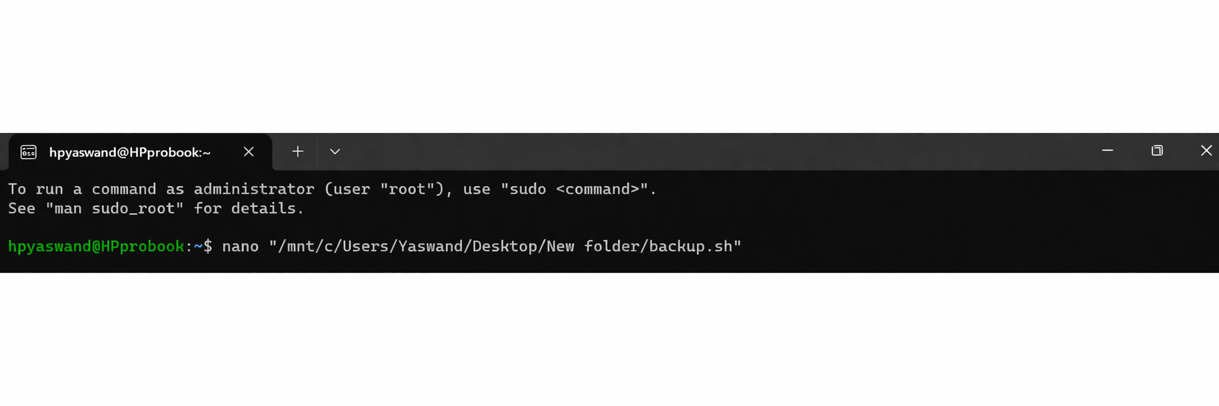
Step 2:
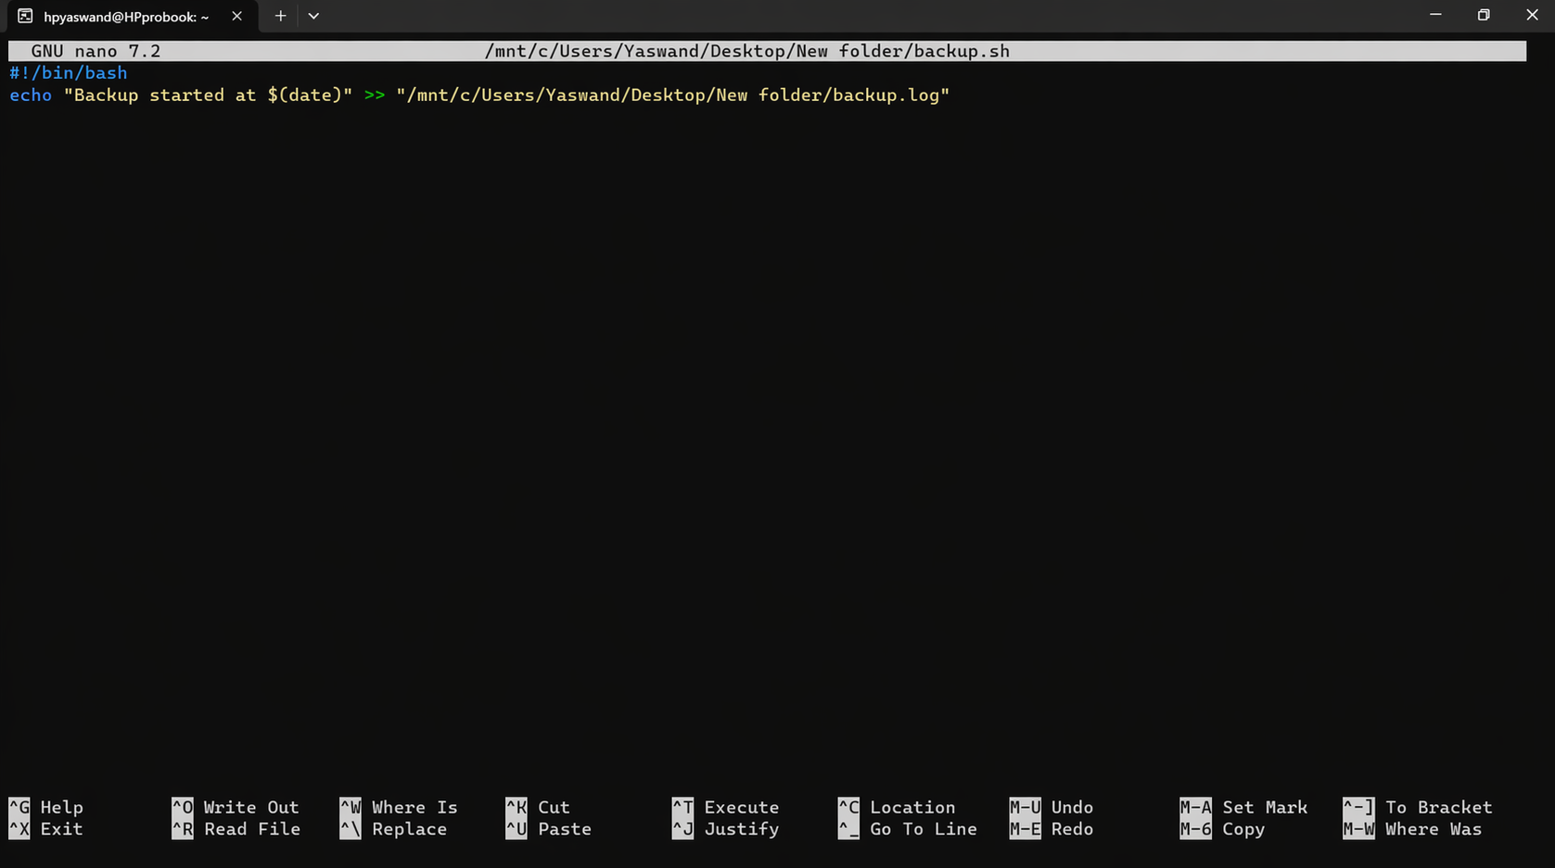
Step 3:
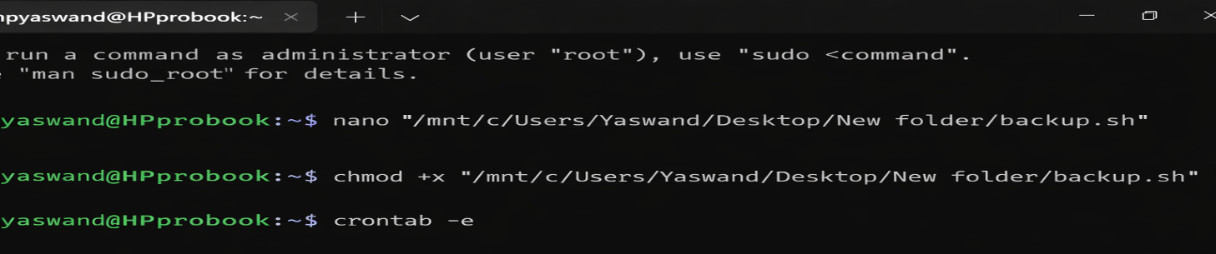

Step 4:
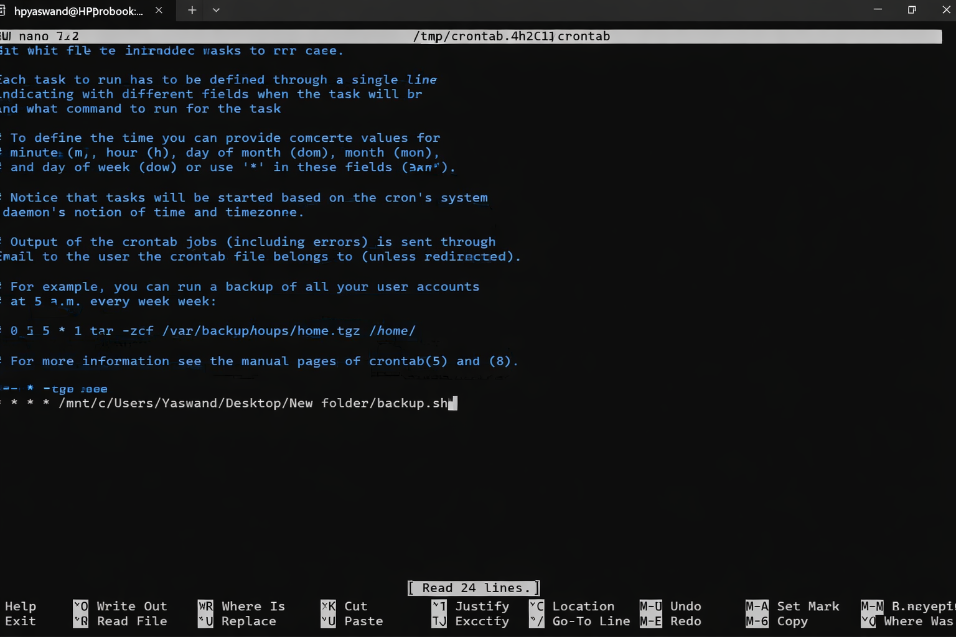
OUTPUT:
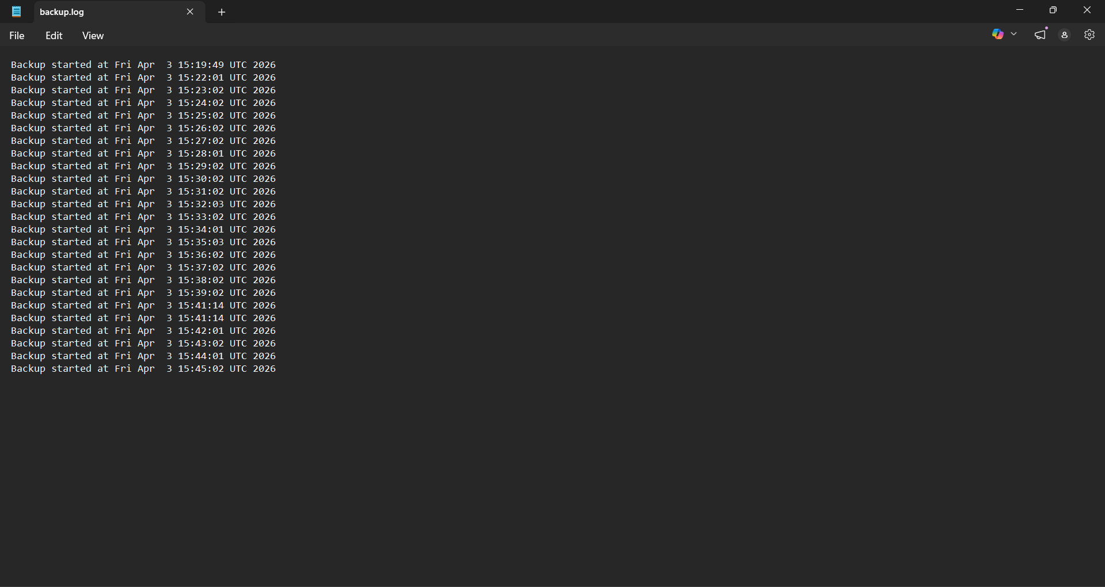

RESULT:
The cron job executed the shell script successfully at the scheduled interval. A log file was created, and new timestamp entries were appended automatically, confirming that background job scheduling with cron works as intended.

